PROJECT DOCUMENTATION
EduGenie
Google Gemini Powered Learning Assistant
A lightweight AI-powered educational assistant for question answering, concept explanation, quiz generation, summarization, and personalized learning paths.
Field | Details
Project Type | AI-Powered Educational Web Application
Backend | FastAPI
Frontend | HTML + CSS
AI Services | Google Gemini API / LaMini-Flan-T5
Programming Language | Python

TEAM MEMBERS:
1.Elakiya P (TEAM LEADER)- elakiya.p.25ds013@gmail.com
2.Agalya R- agalya.r.25ds001@gmail.com
3.Lavanya B- lavanya.b.25ds021@gmail.com
4.Nagajothi M- nagajothi.m.25ds025@gmail.com

Project Overview – EduGenie
EduGenie – Google Gemini Powered Learning Assistant is an AI-based educational web application designed to help students learn in a simple, interactive, and personalized way. The system uses Google Gemini AI and a local AI model to provide different learning services through a single platform.
The application provides features such as Question & Answer, topic explanation, text summarization, quiz generation, quiz evaluation, and personalized learning-path recommendations. It is developed using Python and FastAPI for the backend, with HTML, CSS, and JavaScript for the frontend.
EduGenie aims to reduce the difficulty of finding learning resources and provides students with quick explanations, practice questions, summaries, and structured learning guidance in one place.

Abstract
EduGenie is a lightweight AI-powered educational assistant designed to simplify learning through generative AI. The application allows learners to ask questions, understand complex concepts through simplified explanations, generate quizzes, receive personalized learning recommendations, and summarize long educational passages. The supplied project describes a FastAPI backend with a simple HTML and CSS frontend, combining lightweight/local AI processing with cloud-based AI capabilities.

Introduction
Modern learners often need quick explanations, revision support, self-assessment, and structured guidance while studying. EduGenie addresses these needs through a single web interface. The project uses modular Python components so that different learning functions can be maintained separately. The supplied documentation describes the application as suitable for students and self-learners and emphasizes accessibility through a lightweight web interface.

Problem Statement
Students may spend considerable time searching for explanations, preparing practice questions, summarizing long passages, and deciding what to study next. EduGenie brings these tasks together in one educational assistant. The project focuses on making learning content concise, understandable, interactive, and adaptable to the learner's needs.

Objectives
- Provide question-and-answer support for academic and general knowledge topics.
- Explain complex concepts in simple and readable language.
- Generate multiple-choice quizzes from a topic or passage.
- Summarize lengthy educational content for quick revision.
- Create structured learning recommendations from beginner to advanced level.
- Provide a simple web interface backed by FastAPI REST endpoints.

Scope of the Project
The scope covers five primary learning functions: Q&A, explanation, quiz generation, summarization, and learning-path recommendations. The application is designed to run locally through a FastAPI server while using cloud-based Gemini services where required. The supplied project also identifies possible future extensions such as voice interaction, multilingual support, mobile access, progress tracking, gamification, LMS integration, and image/PDF input.

System Requirements
Category | Requirement
Programming Language | Python 3.10+
Backend | FastAPI
Server | Uvicorn
Frontend | HTML and CSS
Templating | Jinja2
AI | Google Gemini API and LaMini-Flan-T5
Packages (requirements.txt) | fastapi, uvicorn, google-generativeai, transformers, torch, jinja2

Technologies Used
Technology | Role in EduGenie
Python | Core implementation language.
FastAPI | RESTful backend API.
Uvicorn | ASGI server used to run the application locally.
HTML + CSS | User interface and responsive styling.
Jinja2 | HTML templating.
Google Gemini | Generative AI for Q&A, quiz, summary, and learning recommendations.
LaMini-Flan-T5 | Lightweight model used for concept explanation in the supplied project workflow.

The supplied project document describes Gemini 1.5 Pro for Q&A, summarization, quiz generation and learning paths, and LaMini-Flan-T5-783M for concept explanation. The implementation screenshots supplied with this request also show a Gemini GenerativeModel call in the summary module

System Architecture
The architecture connects the learner-facing HTML/CSS interface to a FastAPI backend. The backend routes requests to the appropriate learning module, which uses the configured AI service and returns the generated result to the frontend.
Flow: User → HTML/CSS Frontend → FastAPI Backend → one of five learning modules (Q&A, Explanation, Quiz, Summary, Learning Path) → Google Gemini AI API / LaMini-Flan-T5 → Response returned to the User.

Five Learning Modules
- Q&A (Ask Questions)
- Explanation (Simplify Concepts)
- Quiz (Generate Quizzes)
- Summary (Summarize Text)
- Learning Path (Personalized Plan)

Project Folder Structure
The supplied project organizes the application into separate Python modules, templates, styling, and dependency files. The folder structure shown in the implementation screenshot contains:
- explanation_module.py
- gemini_client.py
- learning_path.py
- main.py
- qna.py
- quiz_module.py
- summary_module.py
- templates/index.html
- static/style.css
- requirements.txt

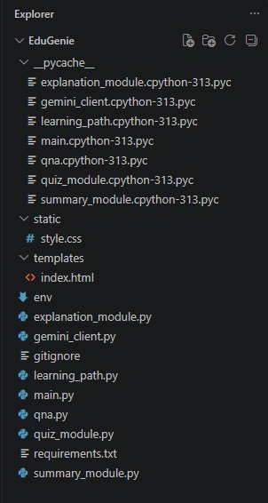

EduGenie project folder structure shown in Visual Studio Code.

.

Functional Modules

Explanation Module
The explanation module is intended to simplify complex topics into concise, context-aware educational explanations. The supplied project associates this function with the lightweight LaMini-Flan-T5 model.

Q&A Module
The Q&A module accepts a learner's question and uses Gemini-based generation to provide an answer across academic and general topics.

Quiz Module
The quiz module generates three multiple-choice questions from a supplied passage. Each question contains four options, and the generated output is structured as JSON for integration with the application.

Summary Module
The summary module converts long passages into concise versions for quick revision while retaining the core information.

Learning Path Module
The learning-path function creates a structured plan from beginner to advanced concepts and may include learning resources such as videos, articles, or books.

Backend API
The supplied project defines RESTful endpoints for each major function. The endpoints are connected to their corresponding module logic in the FastAPI backend.
Endpoint | Purpose
/qa | Question answering
/explain | Concept explanation
/quiz | Quiz generation
/summarize | Text summarization
/learn/recommendations | Personalized learning recommendations

Frontend Development
The frontend is implemented using HTML and CSS. The main page provides sections for Ask a Question, Need an Explanation, Summarize a Paragraph, Generate a Quiz, and Get Learning Recommendations, each with a text input and submit button. CSS is used for responsive layout, buttons, input areas, and the result container.
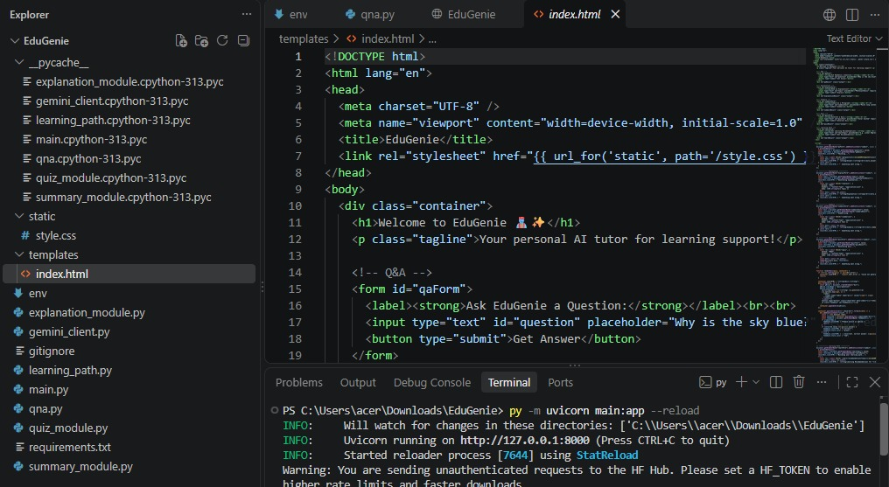
index.html source shown in the VS Code editor, referencing style.css via Jinja2's url_for.

Implementation Details

Dependency Configuration
The supplied requirements.txt lists the following dependencies:
- fastapi
- uvicorn
- google-generativeai
- transformers
- torch
- jinja2

Gemini Client Setup
The gemini_client.py module loads environment variables using dotenv, retrieves the Gemini API key from the environment, and raises a runtime error with a clear message if the key is missing, ensuring the application fails safely when misconfigured.
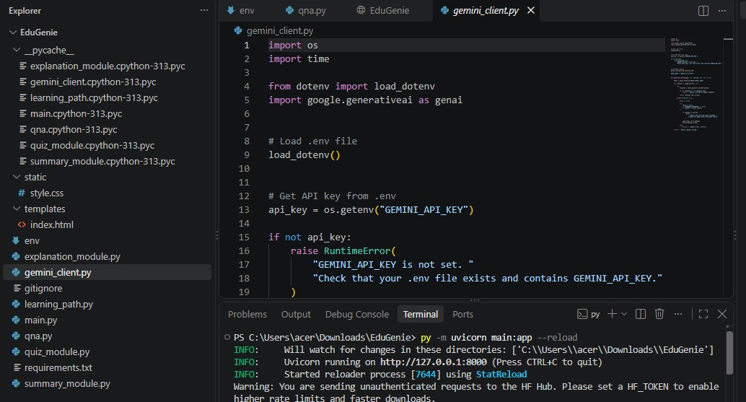
gemini_client.py implementation shown in Visual Studio Code.

Summary Module Code
The supplied summary_module.py shows a summarize_text function that creates a Gemini GenerativeModel, builds a prompt asking for a simple-language summary, generates content, and returns the response text. An exception handler returns an error message if generation fails.

Application Entry Point
main.py assembles the FastAPI application, mounts static files and Jinja2 templates, and imports the core functions from each module (explain_topic, answer_question_with_gemini, generate_quiz, summarize_text, get_learning_recommendations) to expose them through the backend routes.
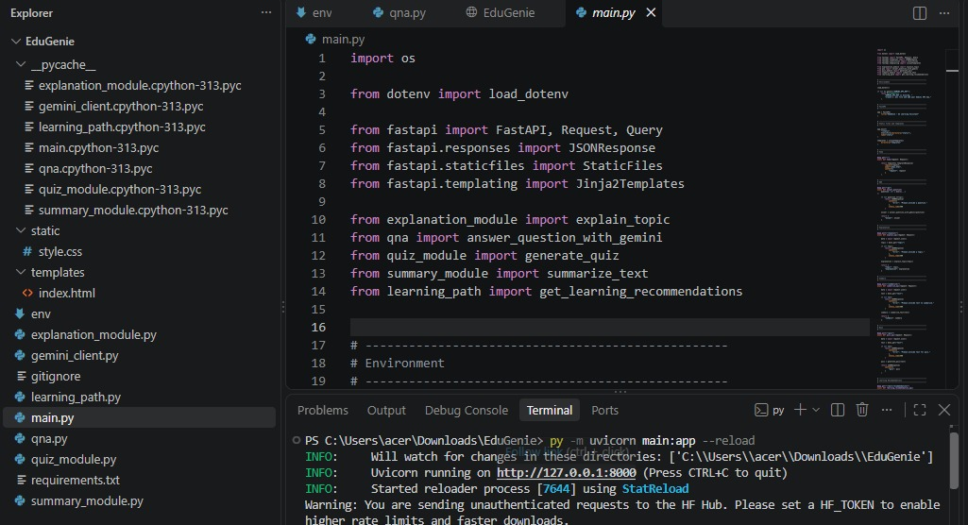
main.py implementation shown in Visual Studio Code.

Project Workflow
- The learner opens the EduGenie web interface.
- The learner selects a task such as Q&A, explanation, quiz, summary, or learning recommendations.
- The learner enters a question, topic, or educational passage.
- The frontend sends the request to the FastAPI backend.
- FastAPI routes the request to the appropriate module.
- The module prepares the required prompt and invokes the configured AI model/service.
- The generated response is processed and returned to the frontend.
- The result is displayed to the learner in the web interface.

Local execution in the supplied project is described using Uvicorn with the command uvicorn main:app --reload, followed by access through the local address 127.0.0.1:8000.

Testing and Functional Verification
Test Case | Expected Function
Ask a question | Display an AI-generated answer.
Get an explanation | Return a simplified explanation of the topic.
Generate a quiz | Generate three MCQs with four options each.
Summarize content | Return a concise version of the supplied text.
Learning recommendation | Return a structured learning plan from beginner to advanced.

Application Output
This section presents the actual rendered output of the EduGenie web application, separate from the source code shown earlier.
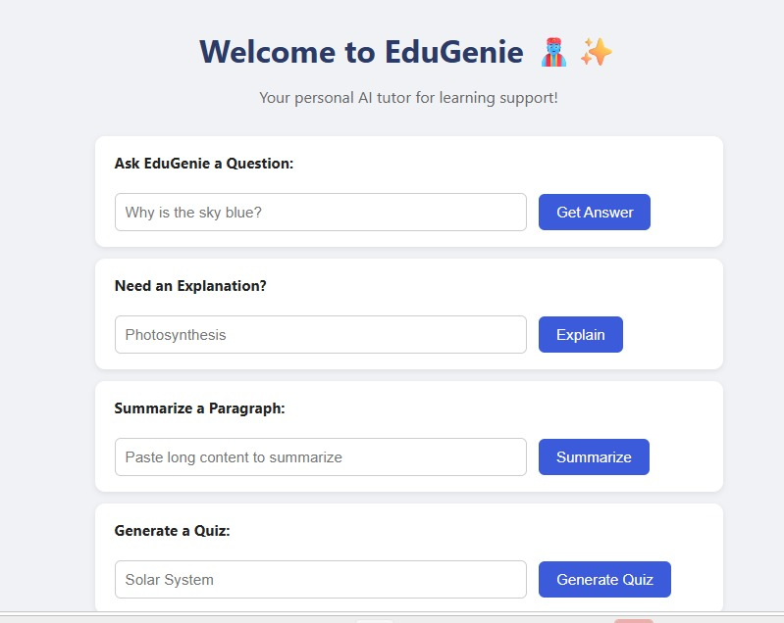
Rendered EduGenie welcome page with the Q&A, Explanation, Summary, and Quiz sections.
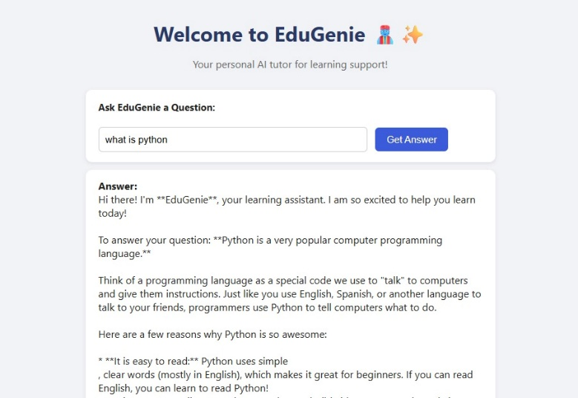
Sample output — question “what is python” with the AI-generated answer displayed below.

Module Outputs
- Explanation: returns a simplified, easy-to-read explanation for the topic entered.
- Summary: returns a concise version of the pasted passage, retaining key information.
- Quiz: returns three multiple-choice questions with four options each, and checks the selected answer.
- Learning Path: returns a structured beginner-to-advanced study plan with suggested resources.

Advantages
- Combines multiple learning-support functions in one interface.
- Uses generative AI to produce dynamic educational responses.
- Provides simplified explanations for easier understanding.
- Supports self-assessment through automatically generated quizzes.
- Provides concise summaries for revision.
- Offers structured learning recommendations.
- Uses a modular backend structure that can be extended with additional functions.
- The project is designed around a lightweight web interface and FastAPI backend.

Limitations and Challenges
The supplied project conclusion identifies challenges including maintaining accuracy in AI-generated responses, performance across devices, balancing personalization with general usability, and addressing data privacy concerns. The project describes continuous testing, prompt fine-tuning, UI optimization, and attention to privacy as part of addressing these challenges.

Future Enhancements
- Voice-based interaction for hands-free learning.
- Multilingual support to reduce language barriers.
- A mobile application with possible offline features.
- Progress-tracking dashboards and learning analytics.
- Gamification such as badges, streaks, and challenges.
- Adaptive learning paths based on learner strengths and weaknesses.
- Group study sessions and teacher/parent dashboards.
- Integration with Learning Management Systems such as Moodle or Google Classroom.
- Image and PDF input for snapshot-based doubt solving and summarization.
- Real-time synchronization and smart notifications.

Conclusion
EduGenie is presented in the supplied project material as an AI-powered educational assistant that combines cloud-based intelligence with an intuitive web interface. Its main capabilities are question answering, concept explanation, quiz generation, summarization, and personalized learning paths. The modular architecture allows these functions to be developed and maintained independently while the FastAPI backend provides a common interface for the frontend.
The project demonstrates the practical use of generative AI in education by turning static learning tasks into interactive activities. The supplied documentation also identifies future opportunities such as voice interaction, multilingual learning, mobile access, progress analytics, gamification, LMS integration, and image/PDF-based learning support.

References
- Google AI for Developers – Gemini API documentation (as cited in the supplied project document).
- FastAPI documentation and user guide (as cited in the supplied project document).
- Jinja2 documentation (as cited in the supplied project document).
- PyPI / Uvicorn documentation (as cited in the supplied project document).
- The supplied EduGenie project documentation and implementation screenshots.

Project Repository link:https://github.com/elakiyap25ds013-lab/EduGenie-AI

